## PuLP **LpProblem** object attributes

*I highlighted a few. You should highlight more as you become familiar with useful ones.*

**Instance Variables**

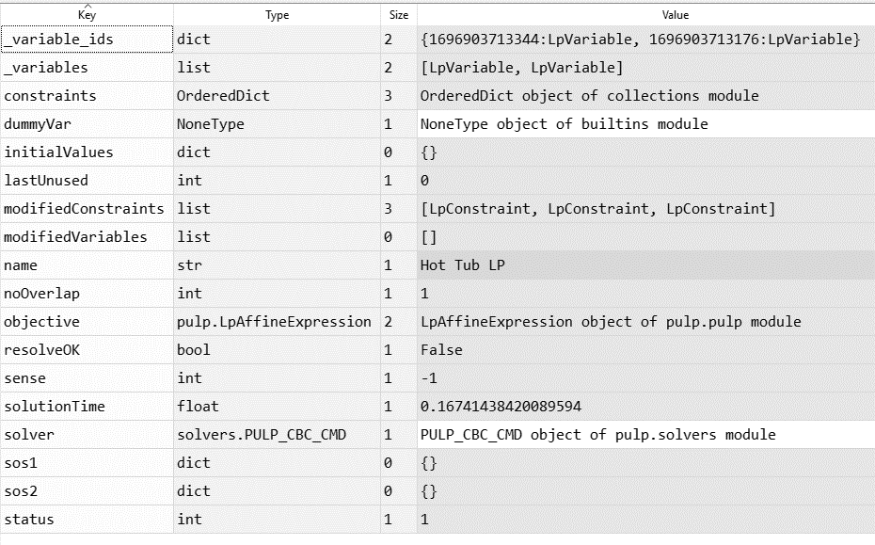

**Object methods**

['__class__',

'__delattr__',

'__dir__',

'__eq__',

'__format__',

'__ge__',

'__getattribute__',

'__getstate__',

'__gt__',

'__hash__',

'__iadd__',

'__init__',

'__le__',

'__lt__',

'__ne__',

'__new__',

'__reduce__',

'__reduce_ex__',

'__repr__',

'__setattr__',

'__setstate__',

'__sizeof__',

'__str__',

'__subclasshook__',

'add',

'addConstraint',

'addVariable',

'addVariables',

'assignConsPi',

'assignConsSlack',

'assignVarsDj',

'assignVarsVals',

'coefficients',

'copy',

'deepcopy',

'extend',

'fixObjective',

'getSense',

'get_dummyVar',

'infeasibilityGap',

'isMIP',

'normalisedNames',

'numConstraints',

'numVariables',

'resolve',

'restoreObjective',

'roundSolution',

'sequentialSolve',

'setInitial',

'setObjective',

'setSolver',

'solve',

'unusedConstraintName',

'valid',

'variables',

'variablesDict',

'writeLP',

'writeMPS']